|  |
| --- |
| South Africa Livelihood Zone Profile  59201 – Lowveld Open Access Mixed Farming (*ZALCM*) |
| Zone Description |

This livelihood zone covers parts of Limpopo and Mpumalanga. In Vhembe District in Limpopo, the zone comprises of rural villages in Mutale, the lowveld eastern part of Thulamela, and the south-eastern lowveld corner of Makhado. In Mopani District, the zone covers most of Greater Giyani (except for the towns, the National Parks and the Lowveld Open Access Irrigated Cropping zone (ZALOI/59302); the eastern and northern part of Greater Letaba; and the northern corner of Greater Tzaneen and a small section of Ba-Phalaborwa. In Mpumalanga, the livelihood zone lies in three parts of Ehlanzeni District: the eastern inhabited part of Bushbuckridge (excluding the National Parks); a narrow strip in Mbombela; and the south-eastern corner of Nkomazi at the confluence of the Swaziland and Mozambique borders.

Figure 1: Map of the livelihood zone

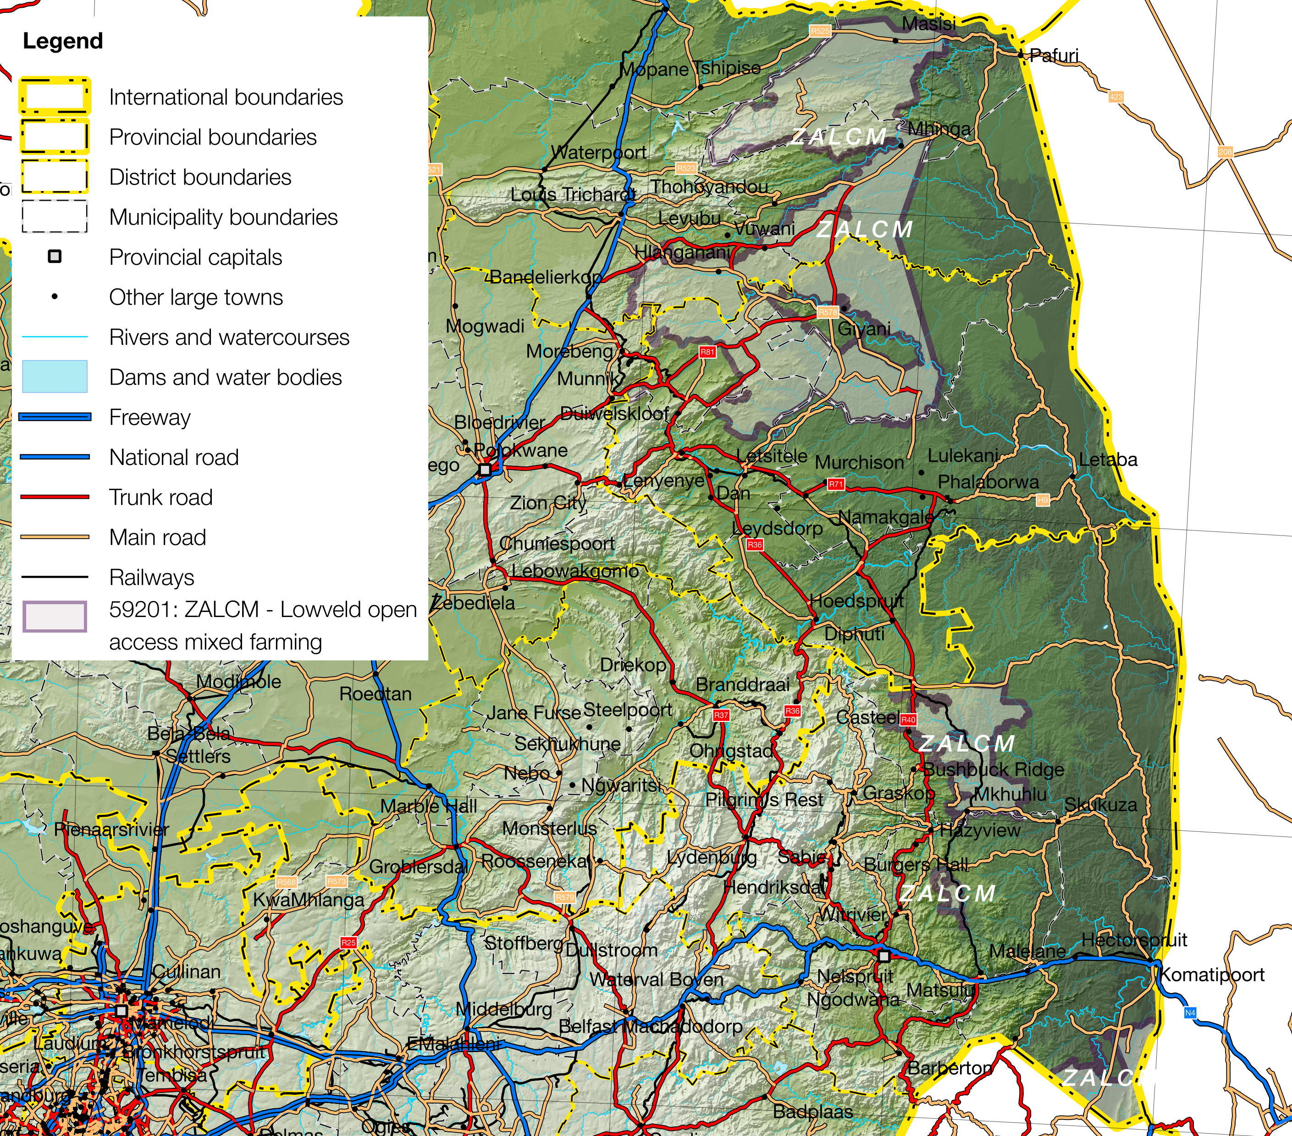

Projection: Albers Equal Area with Standard Parallels at 24.2 ªS and 32.8 ªS, Longitude of Centre at 25.1 ªE..

Sources of data: Open Street Map, Highways (<http://wiki.openstreetmap.org/wiki/Planet.osm>) for the road lines, Shuttle Radar Topography Mission (SRTM) 3 version 2.1 (<http://www2.jpl.nasa.gov/srtm/>) for the elevation and relief shading and Agricultural Geo-referenced Information System (AGIS) (<http://www.agis.agric.za/agisweb/agis.html>) for place names, boundaries and rivers.

Figure 2: Livelihood zone location

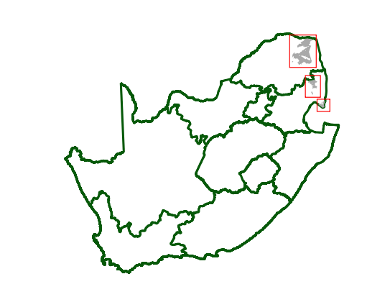

The livelihood zone has been given an alphabetic code (or abbreviation) of ‘ZALCM’ and a numeric code of 59201. These codes distinguish the zone both nationally and internationally, as well as allowing zone name changes and updates if desired (the code should always remain the same).

**Figure 1** is a map of the zone and **Figure 2** shows the location. The Mutale District section is not well served by infrastructure: it is connected to Thohoyandou via district roads, while the R525 skirts the northern boundary and the R540 in the south passes through the middle of Thulamela. The R81 and the links to Greater Giyani and Greater Letaba with Polokwane, while the R529 connects Giyani to Tzaneen. The section of the zone in Bushbuckridge and Mbombela enjoys numerous short connections to the R40 that connects Nelspruit and Ba-Phalaborwa. There is also a railway line that runs through these sections. The Nkomazi section has a good road, the R571, which branches from the Pretoria/Nelspruit - Maputo (Mozambique) N4 highway at Komatipoort. The R571 continues over the border into Swaziland.

Temperatures in the livelihood zone vary from lows of 5°C in winter to highs of 38°C in summer. The mean annual rainfall is between 300-600mm. Rainfall is variable and the recent drought of 2015-16 has been devastating to farming.

Cattle and goats are important for livelihoods in the zone, which make use of the extensive grazing in the surrounding veld. Households also depend on casual labour, remittances and grants.

People in the livelihood zone speak many different home languages, including Tshivenda, Xitsonga, Sepedi and Siswati.

Table I - 2016 Population breakdown of districts and municipalities covered by the livelihood zone, based on the 2011 Census and annual projections

|  |  |  |  |  |
| --- | --- | --- | --- | --- |
| **Province** | **District** | **Municipality** | **Pop. Est. in ZALOI** | **% of Admin Level** |
| Limpopo | Capricorn | Molemole | 692 | 0.60% |
| Mopani | Ba-Phalaborwa | 7,526 | 4.69% |
| Greater Giyani | 198,185 | 76.15% |
| Greater Letaba | 152,759 | 67.14% |
| Greater Tzaneen | 146,444 | 35.24% |
| Vhembe | Makhado | 223,233 | 40.13% |
| Mutale | 85,206 | 85.61% |
| Thulamela | 216,677 | 32.31% |
| **Provincial Total** | | | **1,030,722** | **17.69%** |
| Mpumalanga | Ehlanzeni | Bushbuckridge | 285,138 | 50.52% |
| Mbombela | 5,175 | 0.84% |
| Nkomazi | 65,909 | 16.08% |
| **Provincial Total** | | | **356,222** | **8.18%** |

Source: Statistics South Africa, Census 2011 small area population data and district population projections

The livelihood zone contains the overwhelming majority of people in Greater Giyani (76%), Greater Letaba (67%) and Mutale (85%). Municipalities that still have high proportions of their populations in the zone are: Greater Tzaneen (35%), Makhado (40%), Thulamela (32%) and Bushbuckridge (51%). Nkomazi and Ba-Phalaborwa have significant minorities of their populations in the zone (16% and 5%, respectively), while Molemole and Mbombela have fewer than 1% of their populations in the zone.

The total population in the zone is 1,386,944 (projected to 2016 from the Census 2011) and this is 8.18% and 17.69% of Mpumalanga Province’s and of Limpopo Province’s total populations, respectively. **Table I** shows the breakdown for each municipality.

Figure 3: Gender and age breakdown of the zone population

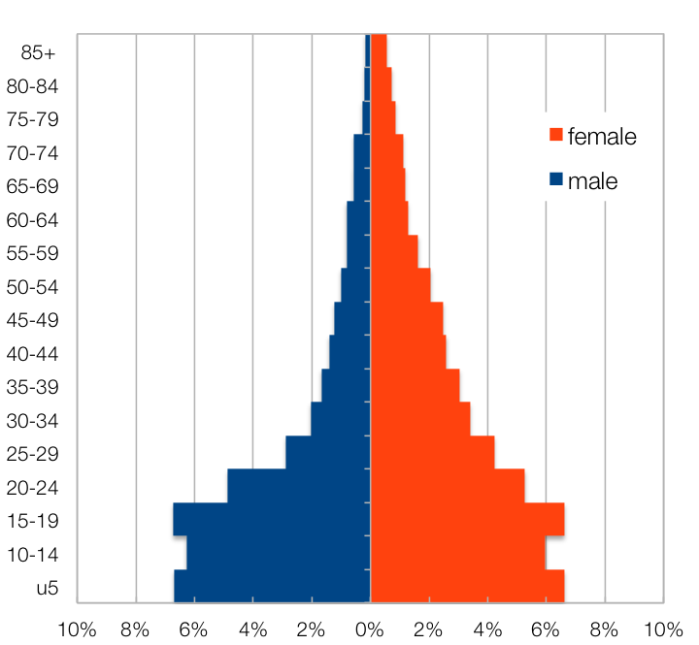

Source: Statistics South Africa, Census 2011 small areas and population database

The age and gender pyramid for the livelihood zone is given in  **Figure 3**. It is important to note the low proportions of adult men (males, including and above the 25-29 age band) in the livelihood zone as well as the high proportion of children (younger than 20). This unbalanced gender and dependency ratio is a consequence of men seeking employment outside of the zone, while women are more likely to remain, looking after family holdings, children and relatives. This is a continuation of the patterns during *apartheid*, when most of the zone was a part of the former *bantustans*, supplying labour to urban, industrial and mining areas. The persistence of this pattern leads to higher dependency ratios and shortages in the zone of human capital, which has impacts on productivity.

|  |
| --- |
| Seasonal Calendar |

Since this is a rural livelihood zone and rural life is determined by agricultural seasons, the information is organised by *consumption year*, which begins with the start of the main dry harvest and runs through to just before the next year's main dry harvest. In this zone, the main dry harvest begins in early May, so the consumption year begins that month and runs up until the end of the following April. The consumption year that interviewees preferred to use in describing their livelihoods is called the *reference year* and this runs from May 2013 to April 2014. It is recorded as a year that is neither very good nor bad but is 'typical', or occurs most frequently. The seasons are summarised in  **Figure 4**.

After harvesting maize and beans through the autumn and winter months from May to July, land clearance and preparation begins in August and may continue up to November (spring). Depending on the onset of the summer rains, planting will commence from October and finish by December. In order to spread risk, more than one planting is undertaken. Weeding (a period of intense activity and one in which work opportunities increase) takes place from December to February, with the some crops being eaten green over March and April. The three main crops grown during this period are maize, groundnuts and beans.

Meanwhile, vegetables are grown from February to October, using residual moisture and irrigation, but not during the peak-labour period for rain fed agriculture in November to January. Casual labour increases during spring and summer with work in preparing fields, weeding and harvesting. Herding work is available all year round but public works breaks off in December and for much of January. Employment outside of the villages takes place in autumn and winter.

Figure 4: Seasonal calendar

|  |  |  |  |  |  |  |  |  |  |  |  |  |  |
| --- | --- | --- | --- | --- | --- | --- | --- | --- | --- | --- | --- | --- | --- |
| **Activity** | Who? | May | Jun | Jul | Aug | Sep | Oct | Nov | Dec | Jan | Feb | Mar | Apr |
| Maize (Land Preparation) | Both |  |  |  |  |  |  |  |  |  |  |  |  |
| (Planting) | Both |  |  |  |  |  |  |  |  |  |  |  |  |
| (Weeding) | Both |  |  |  |  |  |  |  |  |  |  |  |  |
| (Green Consumption) | Both |  |  |  |  |  |  |  |  |  |  |  |  |
| (Dry Harvest) | Both |  |  |  |  |  |  |  |  |  |  |  |  |
| Groundnuts (Land Preparation) | Both |  |  |  |  |  |  |  |  |  |  |  |  |
| (Planting) | Both |  |  |  |  |  |  |  |  |  |  |  |  |
| (Weeding) | Both |  |  |  |  |  |  |  |  |  |  |  |  |
| (Harvest) | Both |  |  |  |  |  |  |  |  |  |  |  |  |
| Beans (Land Preparation) | Both |  |  |  |  |  |  |  |  |  |  |  |  |
| (Planting) | Both |  |  |  |  |  |  |  |  |  |  |  |  |
| (Weeding) | Both |  |  |  |  |  |  |  |  |  |  |  |  |
| (Harvest) | Both |  |  |  |  |  |  |  |  |  |  |  |  |
| Vegetables | Both |  |  |  |  |  |  |  |  |  |  |  |  |
| Casual Labour (crop fields) | Both |  |  |  |  |  |  |  |  |  |  |  |  |
| (domestic work) | Female |  |  |  |  |  |  |  |  |  |  |  |  |
| (herding) | Male |  |  |  |  |  |  |  |  |  |  |  |  |
| (public work) | Both |  |  |  |  |  |  |  |  |  |  |  |  |
| Off-Farm Employment | Both |  |  |  |  |  |  |  |  |  |  |  |  |
| Livestock (Heat and Birth) |  |  |  |  |  |  |  |  |  |  |  |  |  |
| Livestock sales | Male |  |  |  |  |  |  |  |  |  |  |  |  |
| Purchases (Lower Prices) |  |  |  |  |  |  |  |  |  |  |  |  |  |
| (Higher Prices) |  |  |  |  |  |  |  |  |  |  |  |  |  |
| Labour migration | Both |  |  |  |  |  |  |  |  |  |  |  |  |
| Annual Hunger |  |  |  |  |  |  |  |  |  |  |  |  |  |
| Health (Influenza) | Both |  |  |  |  |  |  |  |  |  |  |  |  |
| (Diarrhoea) | Both |  |  |  |  |  |  |  |  |  |  |  |  |

Food prices escalate somewhat towards the end of the year, while diseases such as influenza affect people more in the cold winter months, with diarrhoea string more often in the wet summers.

|  |
| --- |
| Wealth Breakdown |

Wealth in this livelihood zone is determined primarily by two factors:

1. Employment, a result of education and good social connections; and
2. Livestock, especially cattle.

Ownership of a business, such as a spaza shop, bakkie or taxi can also be a determinant but land holdings, which increase only marginally from poor (1 Ha) to rich (2 Ha), are not a determinant.

The wealthiest households, described as the 'better-off', are those with permanent work and a salary of approximately R10,000 per month, which is slightly more than the ‘middle’ who earn approximately R9,000. What distinguishes the ‘better-off’ from the ‘middle’ are livestock: the ‘better-off’ have herds of 15 to 200 head of cattle and 12 to 150 goats compared with 10 to 50 head of cattle and 10 to 40 goats for the ‘middle’. ‘Poor’ and ‘very poor’ households depend instead on social grants and again what distinguishes between the two wealth groups is livestock: the ‘poor’ have 3 to 10 head of cattle and up to 20 goats, while the ‘very poor’ may 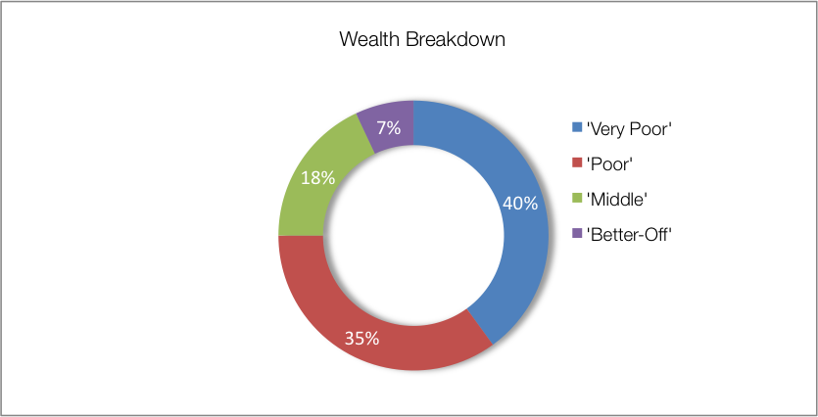still have up to 7 head of cattle and up to 10 goats.

Figure 5: Wealth breakdown in the lowveld open access irrigated cropping livelihood zone

|  |  |  |  |  |  |
| --- | --- | --- | --- | --- | --- |
| Category | Item | Wealth Group (typical value in brackets) | | | |
| 'Very poor' | 'Poor' | 'Middle' | 'Better off' |
| Hh Size |  | 5-14 (10) | 5-10 (8) | 4-8 (7) | 4-8 (7) |
| Land (Ha) | Owned | 0.6-2 (1) | 0.6-2 (1) | 1-3 (2) | 1-3 (2) |
| Cultivated | ½-2 (1) | ½-2 (1) | 0.6-2 (2) | 0.6-2 (2) |
| Livestock (head) | Cattle | 0-7 (4) | 3-10 (5) | 10-50 (20) | 15-200 (50) |
| Goats | 0-10 (5) | 0-20 (7) | 10-40 (20) | 12-150 (25) |
| Income | Main | Grants | Grants | Formal employ | Formal employ/ agric |
| Annual (R) | 34,000 | 52,300 | 179,275 | 302,250 |

Source: Survey output, October 2016

In interviews key informants in the villages tended to estimate larger household sizes, so field teams recorded values in excess to those reported in other surveys, especially the census. The difficulty is in the interpretation of ‘household’: where this study is investigating the dynamics of assets, food sources, cash income sources and expenditure patters, which may go beyond a smaller, nuclear household to a somewhat larger ‘family’ unit. Household sizes are thus 7 to 10 people, which is the basis of the livelihood strategies below and which allows for the sharing of different resources (such as pensions) that would otherwise be confined to a much smaller unit. The values in the study here can be scaled to the appropriate household sizes in other surveys.

It must be noted that outside of the ‘normal’ or ‘typical’ households that are presented in this analysis are exceptions: for example, single mothers without relatives or support structures, abandoned elderly people or orphans. These people have specific needs and are captured by other surveys such as the census and the Continuum snapshot survey below.

|  |
| --- |
| Sources of Food |

Sources of food are expressed in terms of contribution to the minimum human food energy needs, which is 8,800 kJ/person/day. Wealthier households may consume considerably more than this, for example 12,144 kJ/person/day, which is 138% of minimum food needs. Some of this consumption may be wasted, for example when food is thrown away or incompletely eaten. Even the poorest households may consume slightly more than the minimum requirement, for example 101%, or 8,888 kJ/person/day.  **Figure 6** shows the contributions to food energy for each of the main food sources. Bear in mind that the bars *do not* represent quartiles; the numbers of people and households in each wealth group vary considerably.

Figure 6: Sources of food (expressed as percentage of minimum average food energy needs) for each wealth group

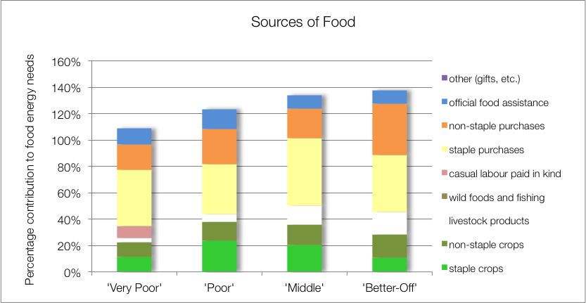

Crops play a significant role in household food access, contributing between 22% and 38% of food energy needs. Food crops grown are green maize, maize, beans, water melons, groundnuts, round nuts (bambara nuts) and pumpkin. Interestingly, the trend across wealth groups shows an initial increase from the ‘very poor’ to the ‘poor’ and then a gradual decline up to the ‘better-off’. This is because the ‘very poor’ lack the capital (human, financial) for investing in crop production, while the wealthier households are able to purchase and prefer more luxury and diverse food items. The ‘poor’ derive the most from their crops, followed by the ‘middle’, obtaining 24% and 20% of their food needs from staple crops only.

Livestock are a significant and important food source with milk making up a proportion of food energy needs that rises steadily with wealth from 3% for the ‘very poor’ to 17% for the ‘better-off’.

Food purchases contribute 62% to 82% of food energy needs, rising with increasing wealth. The contribution to food energy from staple food purchases varies from 38% to 51%. This does not following any trend with wealth. Non-staples increase from 19% for the ‘very poor’ to 39% for the ‘better-off’.

Food aid, mostly from school meals, is constant across the wealth groups.

|  |
| --- |
| Sources of Cash Income |

Cash incomes vary considerably across wealth groups, with the 'better off' earning R 302,250 per annum, almost nine times more than the 'very poor', who earn only R34,040 per annum.  **Figure 7** shows this distribution—it must be noted that the bars in the figure are not quartiles, they represent wealth groups and wealth groups are *not* distributed evenly (see Wealth Breakdown, above).

Figure 7: Sources of annual cash income by wealth group

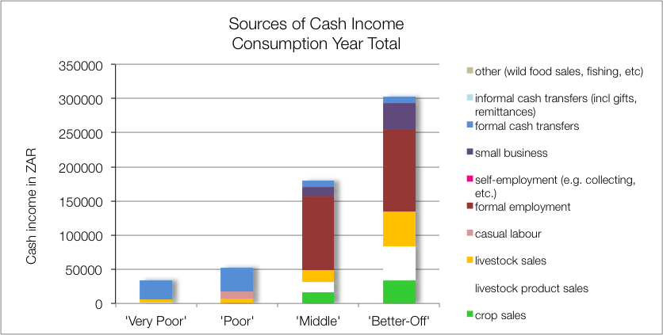

Figure 8: Sources of annual cash income as a percentage of total, by wealth group

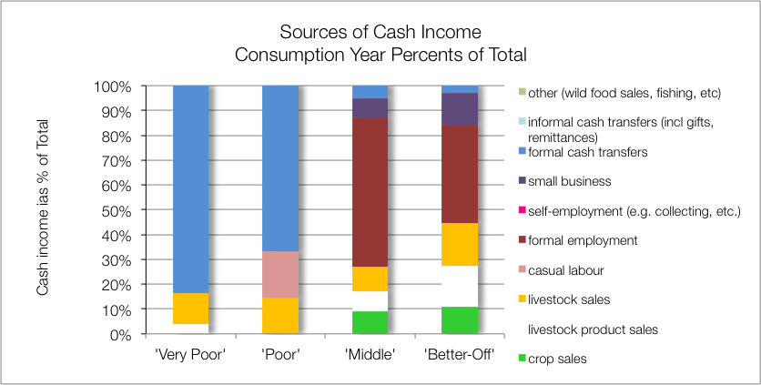

The main sources of cash income in the zone are: formal employment for the 'middle' and 'better off' and cash grants for the 'poor' and 'very poor'. This is in keeping with most surveys that ask for the main livelihood source. This is also apparent when income sources are divided by the total to get proportions, which are shown in  **Figure 8**.

However, the point is to understand how *all* livelihood sources come together to make up an income and this is interesting because for the ‘better-off’, almost half of their cash (45%) is earned from farm activities, crops and livestock. In fact, this is what distinguishes them from the ‘middle’ (cash form employment is quite similar in each wealth group). This does make the ‘better-off’ more vulnerable to environmental shocks such as drought, while the ‘poor and’ and ‘very poor’ are vulnerable to policy changes, inflation and price shocks.

Grants make up 84% and 67% of cash income for the ‘very poor’ and ‘poor’, respectively. The remainder of their cash comes from casual labour (mostly domestic work and agricultural piece work), and the sale of animals or animals products.

|  |
| --- |
| Expenditure |

Absolute expenditures are shown in  **Figure 9** and this varies across wealth groups in line with incomes. As with income, it is usually more instructive to obtain proportions of total expenditure, rather than absolute values. This is done by dividing the expenditure item by the total and the results are graphed in  **Figure 10**.

Figure 10: Annual cash expenditure as a percentage of total, by wealth group

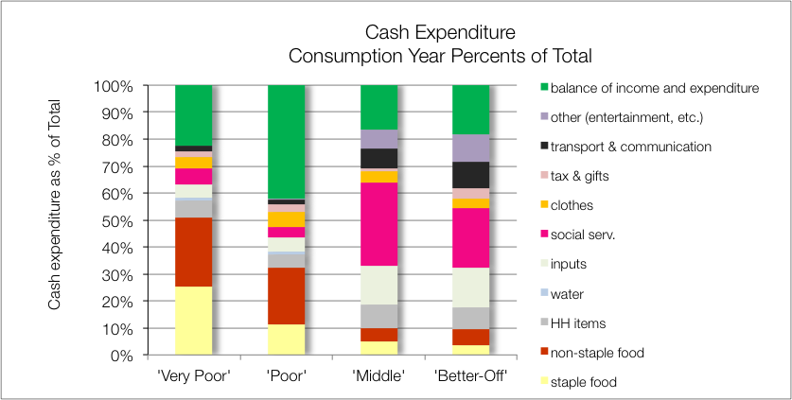

Figure 9: Annual cash expenditure, by wealth group

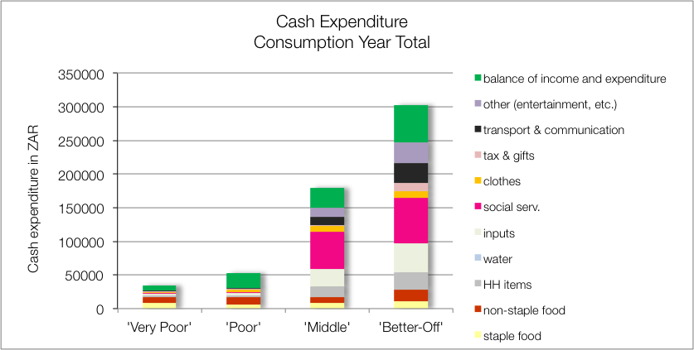

It is clear that social services such as health, schooling and taxes occupy a large proportion of expenditure for the ‘middle’ and ‘better-off’ (31% and 22%, respectively). Agri-cultural inputs are also an important expense for these two wealth groups, costing around 14% to 15%of their income. Both social services and inputs are insignificant expenditures for the ‘very poor’ and ‘poor’.

The ‘very poor’ and ‘poor’ spend most of their money on food instead (they spend 51% and 32% on both staple and non-staple food, respectively).

|  |
| --- |
| Hazards, Vulnerabilities and Response Strategies |

Since ‘poor’ households are dependent on markets for up to half of their food, they are most vulnerable to market-related shocks. These 'market shocks' may consist of: escalating food prices, eroded grants (for example, when they are not adjusted to match consumer inflation) and job losses.

‘Better-off’ households in particular are vulnerable to drought as failed crops can wipe 11% of their cash and 28% of their minimum requirement in food energy (the usually eat 38% more than their minimum requirement, so this loss would not leave them below the minimum requirement line—they would still be at 110% of their food energy requirement). However, a severe drought event that impacts on livestock as well is devastating to this wealth group because it will remove a further 17% from their food sources and 34% from their cash income, effectively making them ‘middle’ or even ‘poor’.

This is precisely what occurred in 2015-2016. Land that was previously productive is now lying fallow due to the drought. Most of the community members, especially the ‘very poor’ and ‘poor’, are selling their livestock because the grazing has been destroyed.

Theft is also a problem especially in Nkomazi (Mbuzini) which is located on the border fence of Mozambique. According to community members, cross-border theft of livestock and other assets such as cars can occur even in the presence of border guards.

Response strategies households may engage in under stress are: switching expenditure, seeking more casual work (usually outside of the village) or selling off assets or belongings.

|  |
| --- |
| Food Insecurity Access Scale |

The majority (44 per cent) of the households in this Livelihood Zone were moderately food insecure. This was followed by 33 per cent of the households who were found to be moderately food insecure. Only four per cent of the households were found to be in a severe state of food insecurity. About 19 per cent of the households were food secure in this livelihood zone.

Figure 13: Food Consumption Scale in the zone

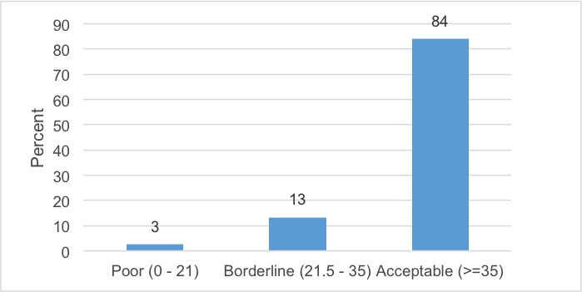

Figure 12: Household hunger scale in the zone

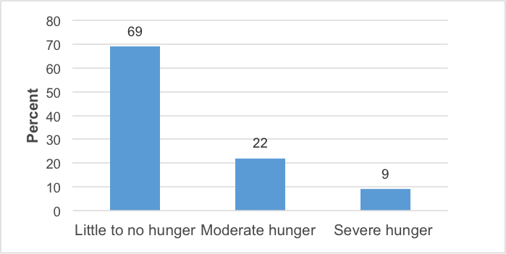

Figure 11: Household food security access scale for the zone

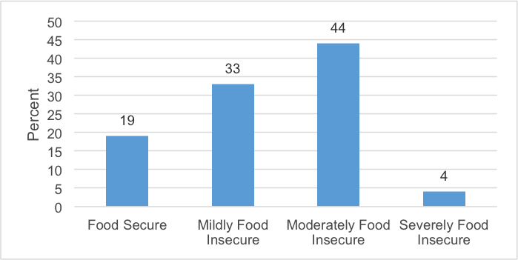

|  |
| --- |
| Household Hunger Scale |

The majority of the households (69 percent) experience no to little hunger and nine per cent of households had severe hunger in this livelihood zone. Only 22 per cent of the households reported a moderate hunger situation – see  **Figure 12**.

Figure 14: Prevalence of stunting in the zone

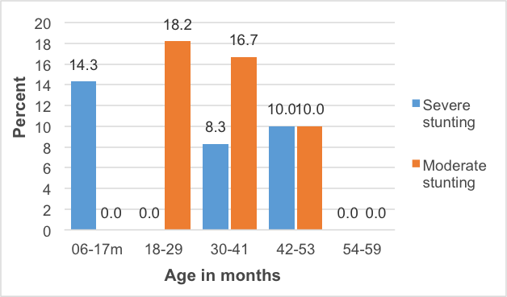

The majority of households – 84 per cent – were consuming acceptable diets. While 13 per cent of the households were within borderline consumption pattern, three per cent of the households were consuming poor diets.

|  |
| --- |
| Nutrition and Anthropometry |

In terms of severe and moderate acute malnutrition, none of the under-five children were found to have severe or moderate acute malnutrition. There is a high prevalence of severe among under-five children within 6-17 months of age and moderate stunting among under-five children of 18-29 months old (**Figure 14**). About 10 per cent of the under-five children were found to be severely stunted and another 10 percent was found to be moderately stunted. No severe and moderate stunting was observed in age groups of 54-59 months old in this livelihood zone.

No under-five children were found to be severe and moderate underweight in all age groupings but 30-41 months old. About eight per cent of the under-five children were underweight in this livelihoods zone.

Figure 15: Prevalence of underweight children in the zone

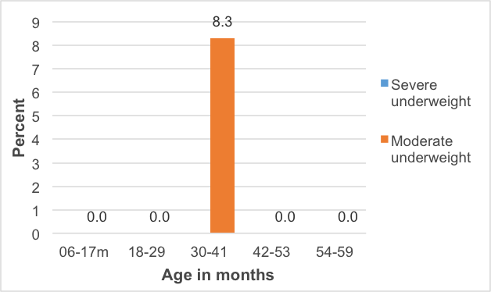

|  |
| --- |
| Conclusions and Recommendations |

Despite good cash earnings from livestock and livestock products, the amounts are still low for the numbers of animals present. To increase production, herds would need more and better management, an investment that would need to be justified through better returns for the owners. These returns could be increased by, for example, support to dairy marketing and greater provision of services and infrastructure to encourage production. Access to capital for investment in farming is crucial to improving production as well—this needs to be made available through ‘softer’ loans, micro-finance schemes and even saving and loans societies (*stokvels)*.

The area is less suited to crop farming but yields could also be improved through greater service provision and market support. Any increased productivity will unlikely benefit all but a few households directly, but will create additional new possibilities through increased work opportunities. For many 'poor' and 'very poor' households, grants will remain the main source of income for some time to come.

Figure 16: Detailed map of the Limpopo section of the livelihood zone showing the sampled sites, other livelihood zones, administrative areas down to enumeration small areas, and infrastructure

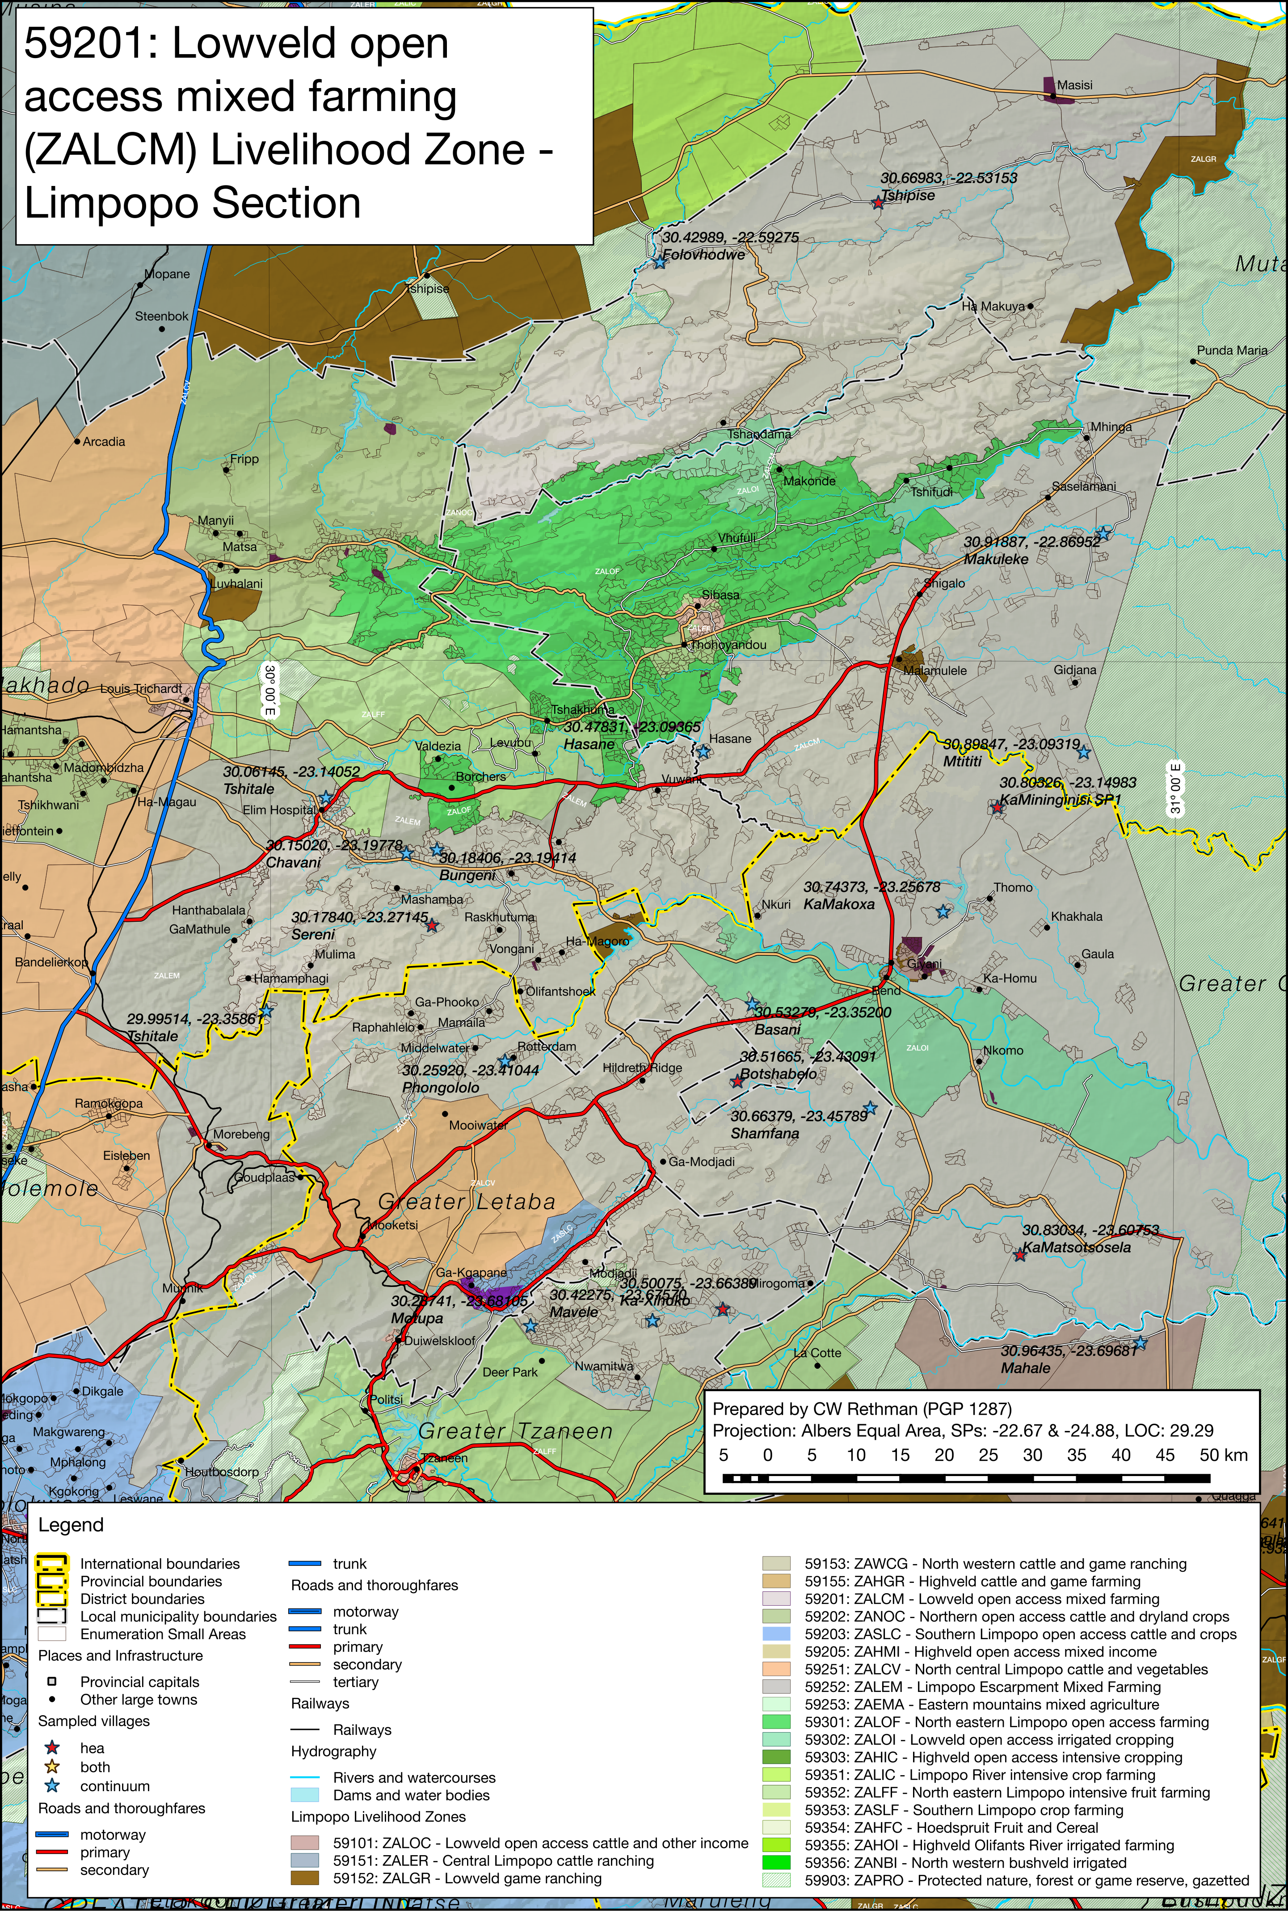

Figure 17: Detailed map of the Bushbuckridge and Mbombela Municipalities (Mpumalanga) section of the livelihood zone showing the sampled sites, other livelihood zones, administrative areas down to enumeration small areas, and infrastructure

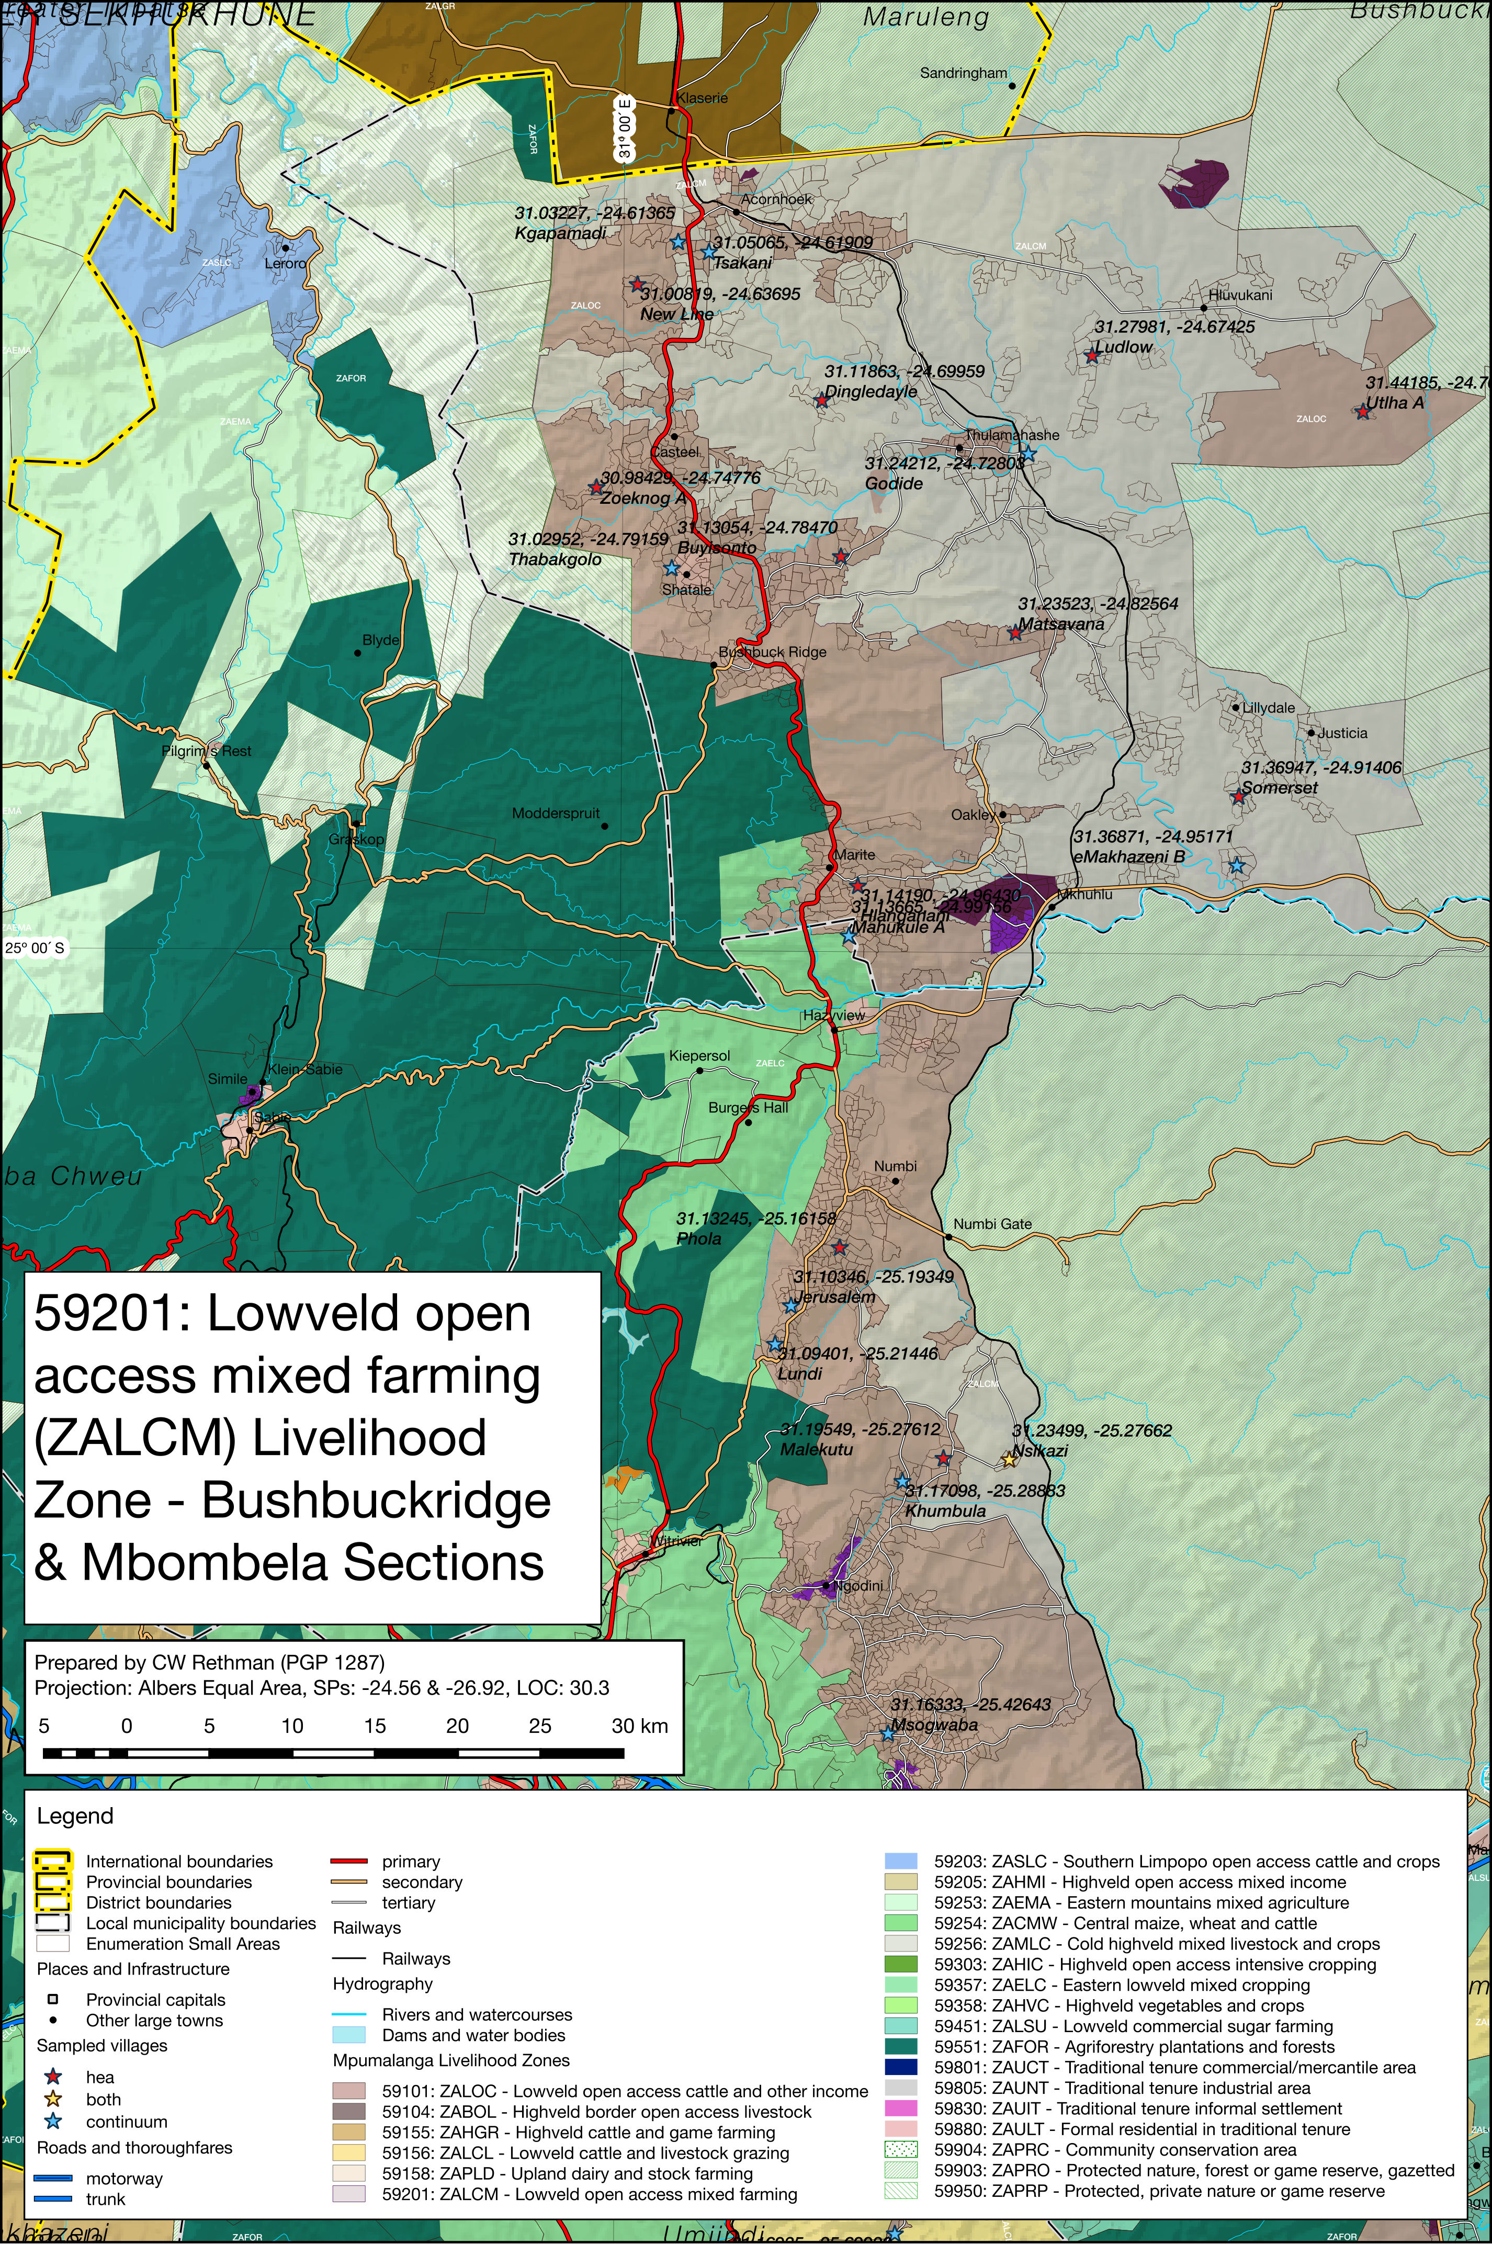

Figure 18: Detailed map of the Nkomazi Municipality (Mpumalanga) section of the livelihood zone showing the sampled sites, other livelihood zones, administrative areas down to enumeration small areas, and infrastructure

